1)fat% Mean-27.4722222,sd 10.63

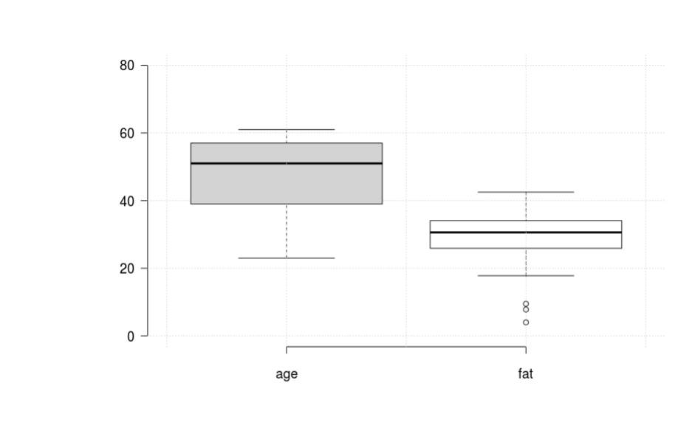age mean-44.94444,sd=12.8462

2) Box plot

3)

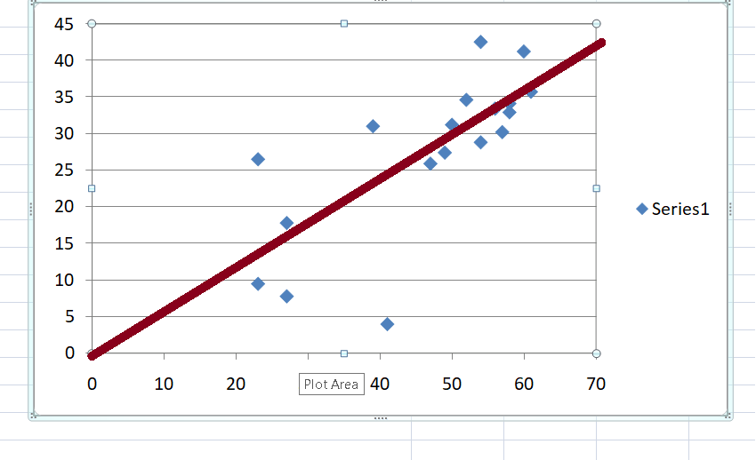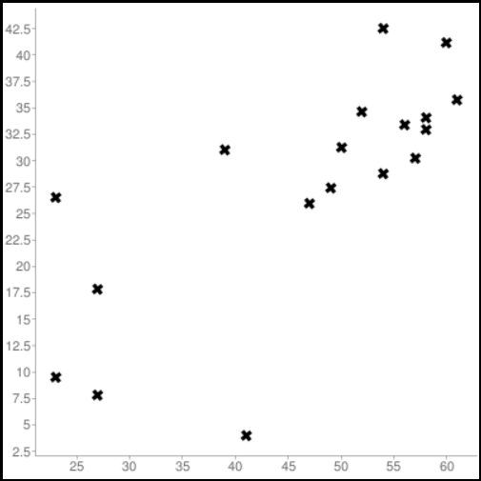

Scatter Plot qq plot

4) Zscore normalization of age and fat

|  |  |  |  |
| --- | --- | --- | --- |
| age | %fat | zscore age | zscore fat |
| 23 | 9.5 | -1.82501 | -1.69036 |
| 23 | 26.5 | -1.82501 | -0.09144 |
| 27 | 7.8 | -1.51363 | -1.85025 |
| 27 | 17.8 | -1.51363 | -0.90971 |
| 39 | 31 | -0.57951 | 0.331802 |
| 41 | 4 | -0.42382 | -2.20766 |
| 47 | 25.9 | 0.043247 | -0.14787 |
| 49 | 27.4 | 0.198935 | -0.00679 |
| 50 | 31.2 | 0.276779 | 0.350613 |
| 52 | 34.6 | 0.432467 | 0.670397 |
| 54 | 42.5 | 0.588155 | 1.413425 |
| 54 | 28.8 | 0.588155 | 0.124883 |
| 56 | 33.4 | 0.743843 | 0.557532 |
| 57 | 30.2 | 0.821687 | 0.256559 |
| 58 | 34.1 | 0.899531 | 0.62337 |
| 58 | 32.9 | 0.899531 | 0.510505 |
| 60 | 41.2 | 1.05522 | 1.291154 |
| 61 | 35.7 | 1.133064 | 0.773857 |

Q5 pearson:Steps involved in calculation of pearson

|  |  |  |  |  |  |  |  |  |  |
| --- | --- | --- | --- | --- | --- | --- | --- | --- | --- |
| age | %fat | zscore age | zscore fat | xy | x2 | y2 |  |  |  |
| 23 | 9.5 | -1.82501 | -1.69036 | 218.5 | 529 | 90.25 |  |  |  |
| 23 | 26.5 | -1.82501 | -0.09144 | 609.5 | 529 | 702.25 |  |  |  |
| 27 | 7.8 | -1.51363 | -1.85025 | 210.6 | 729 | 60.84 |  |  |  |
| 27 | 17.8 | -1.51363 | -0.90971 | 480.6 | 729 | 316.84 |  |  |  |
| 39 | 31 | -0.57951 | 0.331802 | 1209 | 1521 | 961 |  |  |  |
| 41 | 4 | -0.42382 | -2.20766 | 164 | 1681 | 16 |  |  |  |
| 47 | 25.9 | 0.043247 | -0.14787 | 1217.3 | 2209 | 670.81 |  |  |  |
| 49 | 27.4 | 0.198935 | -0.00679 | 1342.6 | 2401 | 750.76 |  |  |  |
| 50 | 31.2 | 0.276779 | 0.350613 | 1560 | 2500 | 973.44 |  |  |  |
| 52 | 34.6 | 0.432467 | 0.670397 | 1799.2 | 2704 | 1197.16 |  |  |  |
| 54 | 42.5 | 0.588155 | 1.413425 | 2295 | 2916 | 1806.25 |  |  |  |
| 54 | 28.8 | 0.588155 | 0.124883 | 1555.2 | 2916 | 829.44 |  |  |  |
| 56 | 33.4 | 0.743843 | 0.557532 | 1870.4 | 3136 | 1115.56 |  |  |  |
| 57 | 30.2 | 0.821687 | 0.256559 | 1721.4 | 3249 | 912.04 |  |  |  |
| 58 | 34.1 | 0.899531 | 0.62337 | 1977.8 | 3364 | 1162.81 |  |  |  |
| 58 | 32.9 | 0.899531 | 0.510505 | 1908.2 | 3364 | 1082.41 |  |  |  |
| 60 | 41.2 | 1.05522 | 1.291154 | 2472 | 3600 | 1697.44 |  |  |  |
| 61 | 35.7 | 1.133064 | 0.773857 | 2177.7 | 3721 | 1274.49 |  |  |  |
| 836 | 494.5 | 2.44E-15 | 9.44E-15 | 24789 | 41798 | 15619.79 | Sums | **pearson=** | **0.741195** |

6) Since Pearson coefficient is positive and close to 1 they are positively correlated and there is a strong correlation between them.